DESTINATION Lake Sammamish State Park. **This is a required trip for all Scouts and adults who are going on the long-term canoe trip in August and have not previously gone on a Troop 166 long-term canoe trip.**
DEPART Meet at Wedgwood Presbyterian Church parking lot at 8:00am Saturday, June 5, 2010. Rosters, maps, driving instructions in the parking lot. The troop will depart at 8:30am sharp.
**Canoes will be loaded onto the trailer and vehicles the night before the trip, 4 June at the parking lot across the street from the church starting at 5:00 pm.**
We will return to the church parking lot around 3:30 pm on Saturday.
LEADERSHIP ADULT: Matt Finlon, (206) 985-7880, cell (206) 931-9046 SCOUT: SPL Stefan Skalbania
PROGRAM This is a single day, canoe outing to expose the Scouts to a typical day of paddling they will experience on the Long Term Canoe Trip. We will be launching and retrieving boats at Sammamish State Park.
All canoes must have a buddy canoe with them and all groups must be at least four canoes big.
ROUTE Located on the southern end of Lake Sammamish. From I-90 east: Take Exit #15. Stay in left exit lane and turn left at light. Head north over I-90 and take first left onto NW Sammamish Rd. Travel .4 miles and turn right into park entrance. Parking lot will be the first road to the left (visible from the road). Park as close as you can to the beach. We will gather the canoes at the right side of the beach.

EQUIPMENT This trip is a day trip. Troop 166 practices Leave No Trace – i.e. leave only footprints, take only pictures – so bring garbage bags, and plan carefully. Bring your 10+ essentials including extra clothing and rain gear in case you dump your canoe. Equipment should be placed in a dry bag or waterproof container. Avoid cotton clothing (like jeans), and stick with polypropylene, fleece and other synthetics.
Scouts must be prepared for potential wet weather and cold and well as hot, sunny conditions. Scouts should have a hat and sunscreen.
Every paddler will be equipped with a life vest. Every canoe will have (2) bailers, an extra paddle, and an extra PFD. Sails should be brought if available.
Work Party: There will be a work party to finish the canoe trailer at the Steckler’s house on Saturday, May 22nd starting at 9:00 am.

FOOD Everyone should have adequate quantities of water to consume during the paddling. Each individual will bring lunch. The lunch break will be held halfway through the canoe trip so Scouts should be prepared to consume their lunch while sitting in their canoes. Stopping for food on the return trip will be at the discretion of the individual drivers. There is a concession stand located at the beach where we are launching and recovering canoes.
FEE NO FEE. The Troop will reimburse drivers for transportation.
RETURN Troop will arrive back at the church around 3:30 pm on Saturday. Troop will call the phone tree contact on the way back.
SIGN-UP Signed permission slips are due Monday May 24th (no meeting on May 31st---Memorial Day) at the troop meeting or no later than Wednesday, June 2, 2010 to Matt Finlon (7305 54th Ave NE).
PERMISSION AND MEDICAL RELEASE FORM:

Scout ___________________________ has my permission to participate in the Lake Sammamish State Park Canoe Outing sponsored by Boy Scout Troop 166.

Contact phone number for any unexpected circumstance:
This phone contact must be available from departure at parking lot to return.

YES NO I will provide transportation for this trip. My vehicle has seat belts for __ passengers.

YES NO I can tow a canoe trailer. YES NO I can carry ____number of canoes on my vehicle roof.

Auto Insurance Company: ____________________________________________
Policy Number: _______________________________
Insurance Coverage: Liability Each Person $______________ Each Accident $___________________
Property Damage $ _________________
Or initial if you meet or exceed Washington State Minimum Requirements ____________________
$25,000 of bodily injury each person, $50,000 of bodily injury each accident, $10,000 property damage. –Amounts from WA. DOL 2006
Driver’s License Number:
Vehicle make Vehicle Model Year Owner’s Name License Plate No. Seat Belts
____________ _______ ____ __________________ ____________ ____________
YES NO I’m available to accompany the Scouts on the outing.

I hereby give permission for any and all medical attention necessary to be administered to my child in the event of an accident, injury, sickness, etc., under the direction of the adults listed on this form or the adult leaders listed on the trip bulletin until such time as I may be contacted. This release is effective for the time during which my child is participating in a Troop 166 Boy Scout outing, including traveling to or from activities. I also hereby assume full responsibility for payment of any such treatment.

Parents’ or Guardians’ Names: __________________________________

Home Address: __________________________________

Home Phone: __________________________________

Work Phone: __________________________________

Health Insurance: __________________________________

Policy Number: __________________________________

Signature of Parent or Legal Guardian: _____________________________________

Date:________________________

Scoutmaster: Bill Montgomery Phone: (206)523-0072
Assistant Scoutmaster: Ron Maxum Phone: (206)523-6587

Coordinating Instructions :

- Depart church parking lot at 8:30 am.
- Arrive at Lake Sammamish State parking lot at 9:00 am.
- Depart Tibbetts Beach at 9:45. Paddle for 2 hours along western shore of lake.
- Stop for lunch at 11:45am until 12:15 pm.
- Paddle across lake to eastern shore and return to launch point—arriving approximately at 2 :15 pm.
- Retrieve canoes and secure to vehicles
- Depart Park at 3:00 pm.
- Arrive at church parking lot at 3:30 pm.

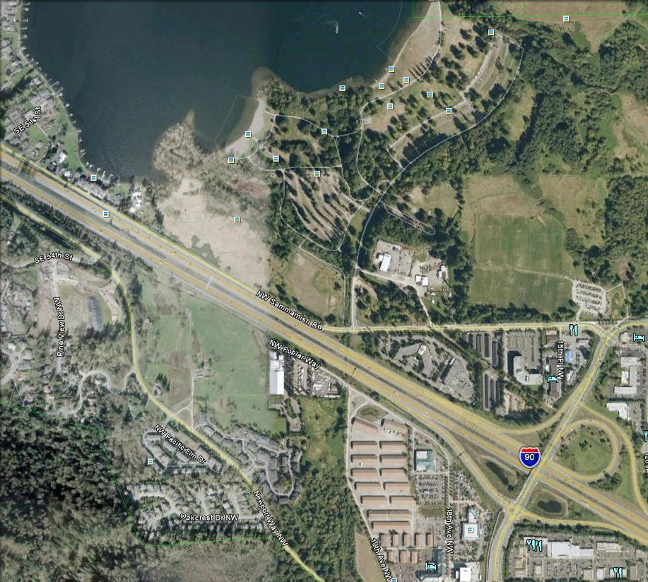
Parking Lot
Launch Site
Exit #15

